**Project Report Template**

**TITLE:Build An Event Management System Using Salesforce.**

**1. INTRODUCTION**

* 1. **Overview**

The project aim is to provide real-time knowledge for all the students who have basic knowledge of Salesforce and Looking for a real-time project. This project will also help to those professionals who are in cross-technology and wanted to switch to Salesforce with the help of this project they will gain knowledge and can include into their resume as well

* 1. **Purpose**

Event management is the process of creating and maintaining an event. This process spans from

the very beginning of planning all the way to post-event strategizing.

**2.** **Problem Definition & Design Thinking**

**2.1 Empathy Map**

Paste the empathy map screenshot

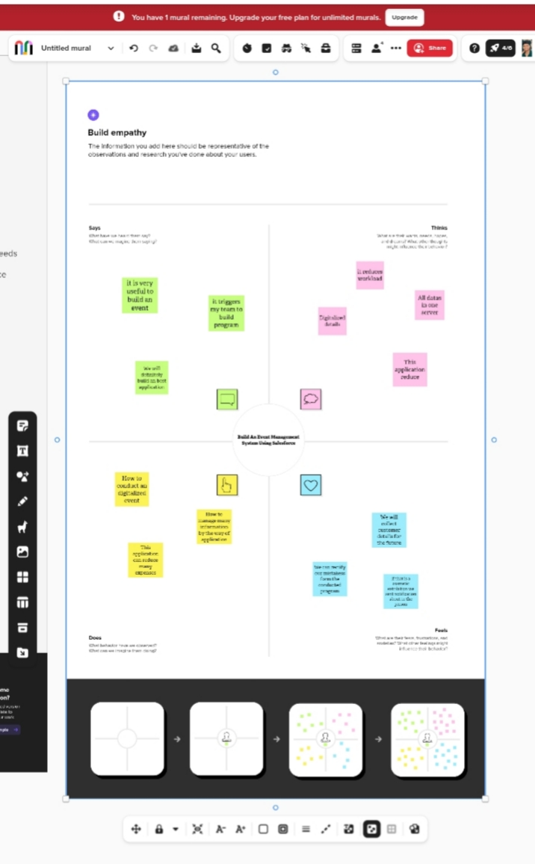

**2.2 Ideation & Brainstorming Map**

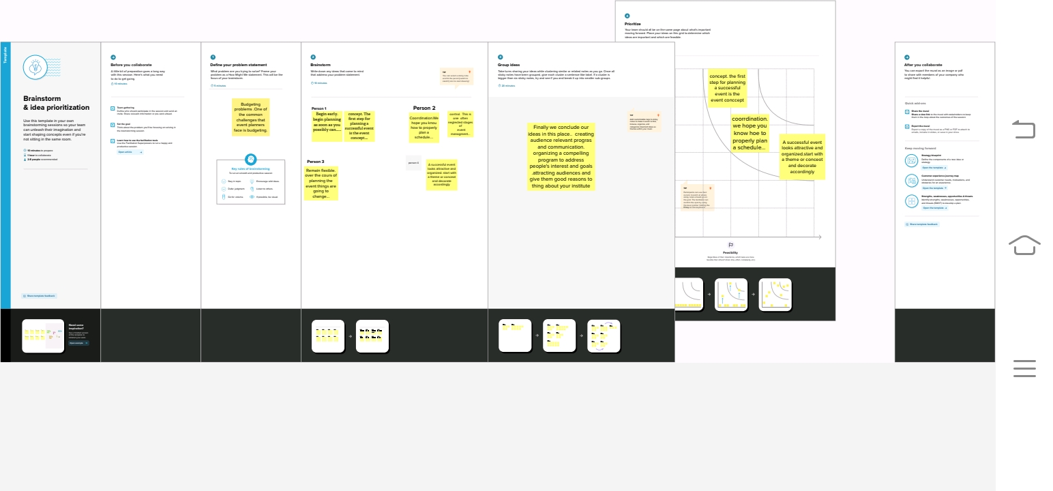

Paste Ideation &nstorming Map screenshot

**3. RESULT**

**3.1 Data Model:**

|  |  |
| --- | --- |
| **Object Name** | **Field in the Object** |
| **Obj - 1 Attendees** | |  |  | | --- | --- | | **Field Label** | **Data Type** | | enter I'D | auto number | |
| **Obj - 2 Event** | |  |  | | --- | --- | | **Field Label** | **Data Type** | | event name | master details relationship with event | |

**4. Trailhead Profile Public URL**

**Team Lead -** [**https://trailblazer.me/id/sivas301**](https://trailblazer.me/id/sivas301)

**Team Member 1 -** [**https://trailblazer.me/id/tamip9**](https://trailblazer.me/id/tamip9)

**Team Member 2 -** [**https://trailblazer.me/id/thens54**](https://trailblazer.me/id/thens54)

**Team Member 3 –** [**https://trailblazer.me/id/veert4**](https://trailblazer.me/id/veert4)

**5. ADVANTAGES & DISADVANTAGE**

ADVANTAGES:

2 Save Time and Money

With direct links to venues and suppliers, event management companies get preferential rates and can negotiate the best prices based on these relationships and our experience. We’ll know the most suitable locations, facilities and support services to meet any clients’ needs – which may not always be the most obvious ones. We can also offer alternative options with the information readily available so you don’t have to spend time searching on google!

List of advantages and disadvantages of the proposed solution

DISADVANTAGE:

**Event planning is a fairly stable career with lots of flexibility. You can work for an events firm, in self-employment, or for a private company. You typically need at least a bachelor's degree to work for an event-planning company. The job can be fun, fast-paced and exciting.**

**6. APPLICATIONS**

Analyze and improve

It reduces many expenses

It saves our time.

**7. CONCLUSION**

In order to using this software we can create larger events by easy way.

**8. FUTURE SCOPE**

The scope of event management as a career in India is vast. It's a thriving industry and is home to a million people. So, if you have a knack for creativity and want to redesign the perceptions of society, the event management industry is all for you